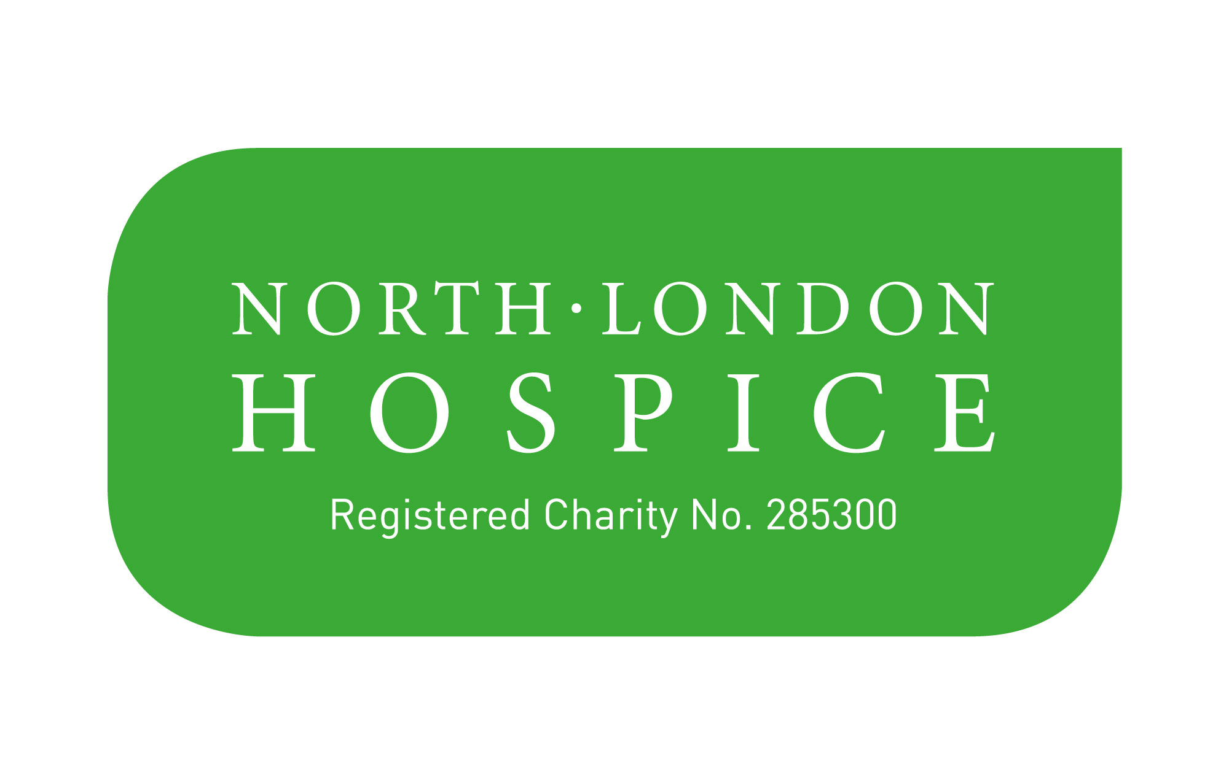Broadcast/ Photo/Video Consent
North London Hospice often takes photography or video film for publicity purposes. These images may appear in printed publications, on our website, social media and on promotional material. We may also send them to news media.
We require your consent and permission to do this. May we use your image now or in the future:
- In printed North London Hospice publicity or promotional literature including leaflets, posters, newsletters and other display material (please circle) YES/NO
- On the North London Hospice website and social media channels e.g facebook, Twitter, Instagram and You Tube (please circle) YES/NO
- In publicity material about our services which we send to the media including local and national press (please circle) YES/NO
I understand that websites and other online media can be seen throughout the world, and not just in the UK where UK law applies (please circle) YES/NO
Please state here, if there are any specific media channels that you do not consent to using your image/video:

I have read and understood the conditions of use that I have agreed to above. Signature: Print Name:
Date:
CONDITIONS
It's North London Hospice's policy that where we are planning to use an image (photography or video) for materials in the public domain, consent must be obtained.
The consent form must be completed before photography/filming takes place. The purpose of the consent form is to provide:
- Information for the person giving consent so they can make an informed decision
- To be clear about which areas consent applies to.
Image consent can be changed or withdrawn at any time by notifying North London Hospice fundraising and communications team. North London Hospice cannot withdraw images already published.

47 Woodside Avenue, London N12 8TT Tel: 020 8343 8841
Registered Charity No. 285300
www.northlondonhospice.org

